

Lab 2

|  |  |
| --- | --- |
| Name | Yaroslav Puhachevskyi |
| Date | 02/03/2026 |
| Student No | S00291035 |
| Student Email | S00291035 |

### **Project Ideas**

Create robotic arms that will play games and grind resources

Or create software for Arduino that will perform a similar function as in the first example

### **GitHub Desktop**

1. Go to <http://github.com> and sign in
2. Install GitHub Desktop from here: <https://desktop.github.com/> and sign-in
3. Using GitHub Desktop, Clone the FirstRepo repository from your GitHub account and screenshot it here   
   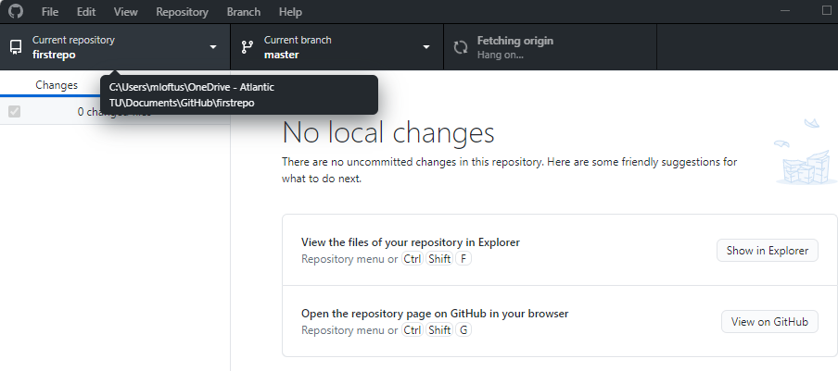
4. **Using Github Desktop**, create a repository called **secondrepo**
5. In your secondrepo folder add a file and save it, then **commit** the change and **push** it to your GitHub account
6. Paste a screenshot below (replace mine) of your pushed **secondrepo** repository on GitHub.com  
   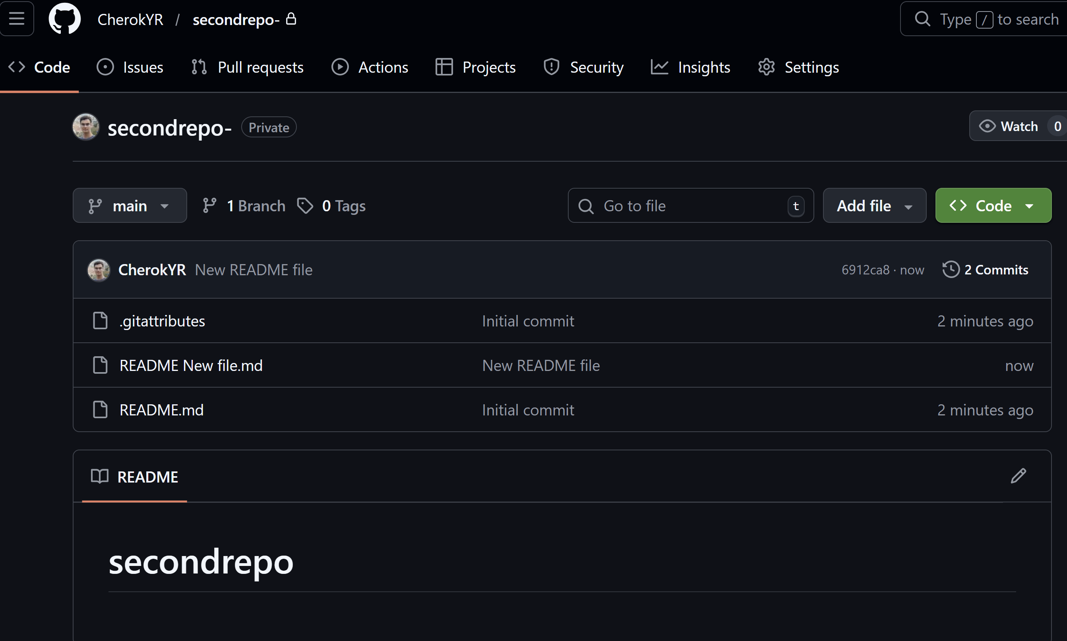
7. Add a Contributor to one of your Github repositories and paste a screenshot to show the details 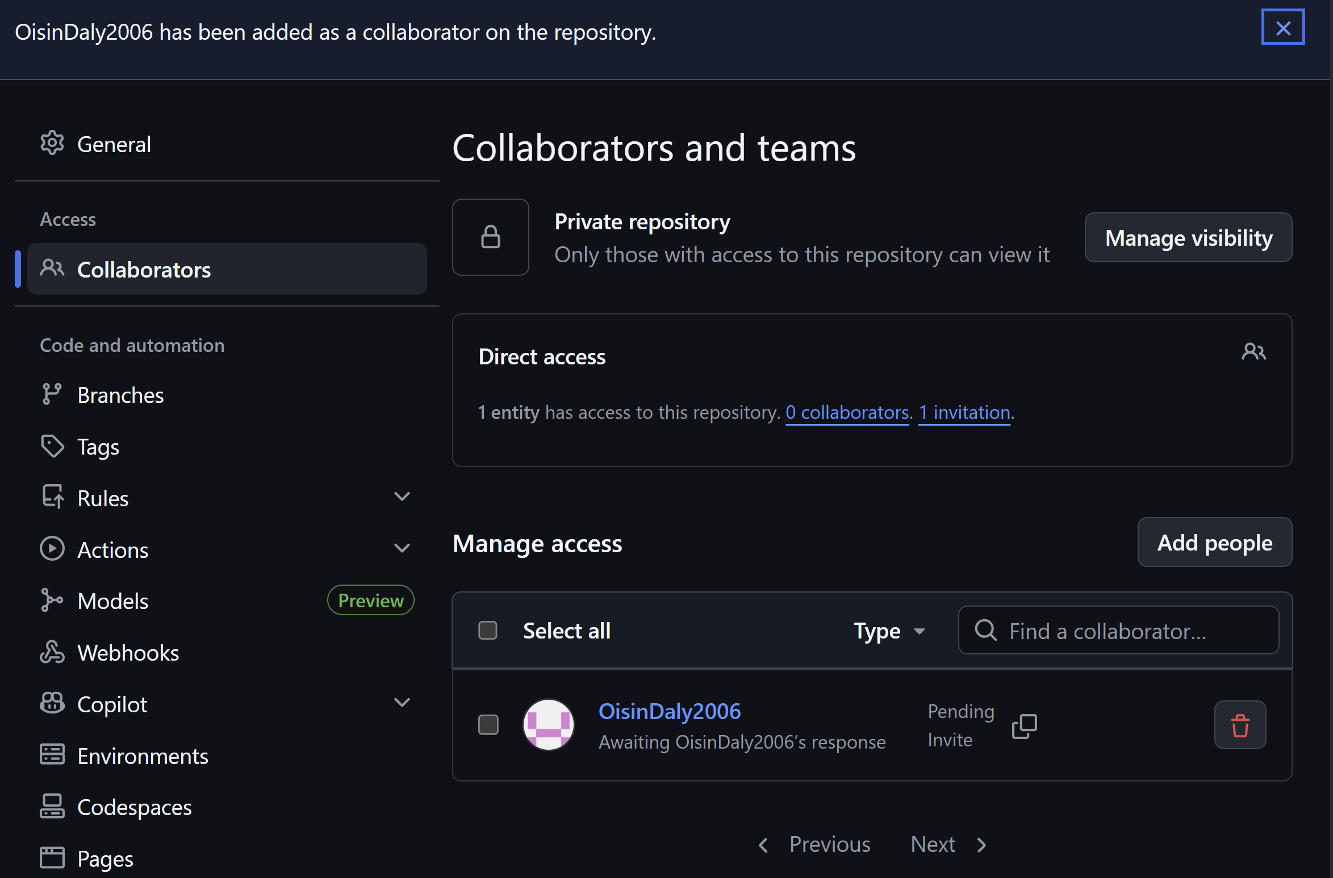
8. Issue a Pull Request to a colleague’s public Github repository suggesting a change to any file - add screenshots of the pull request interaction.

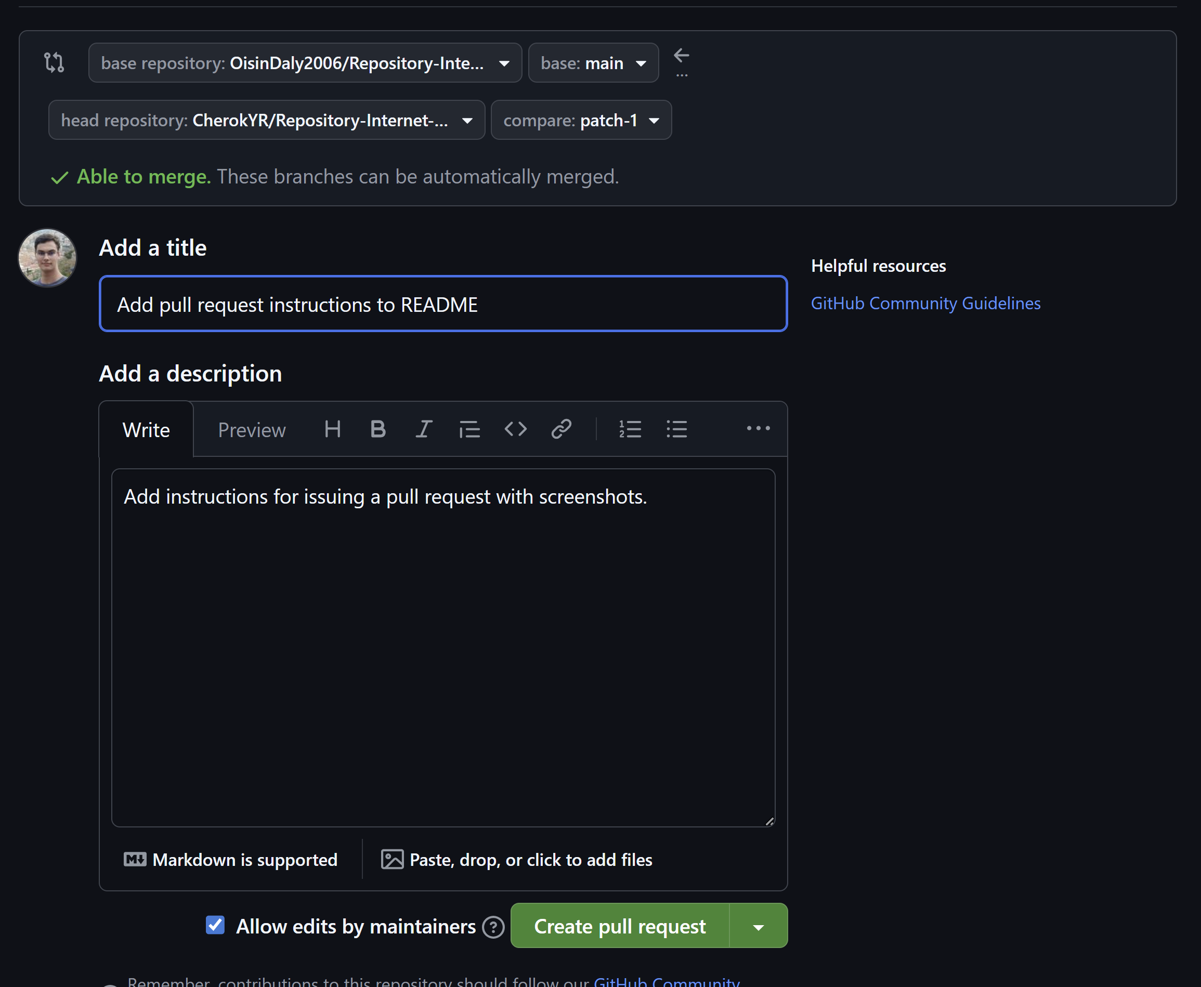

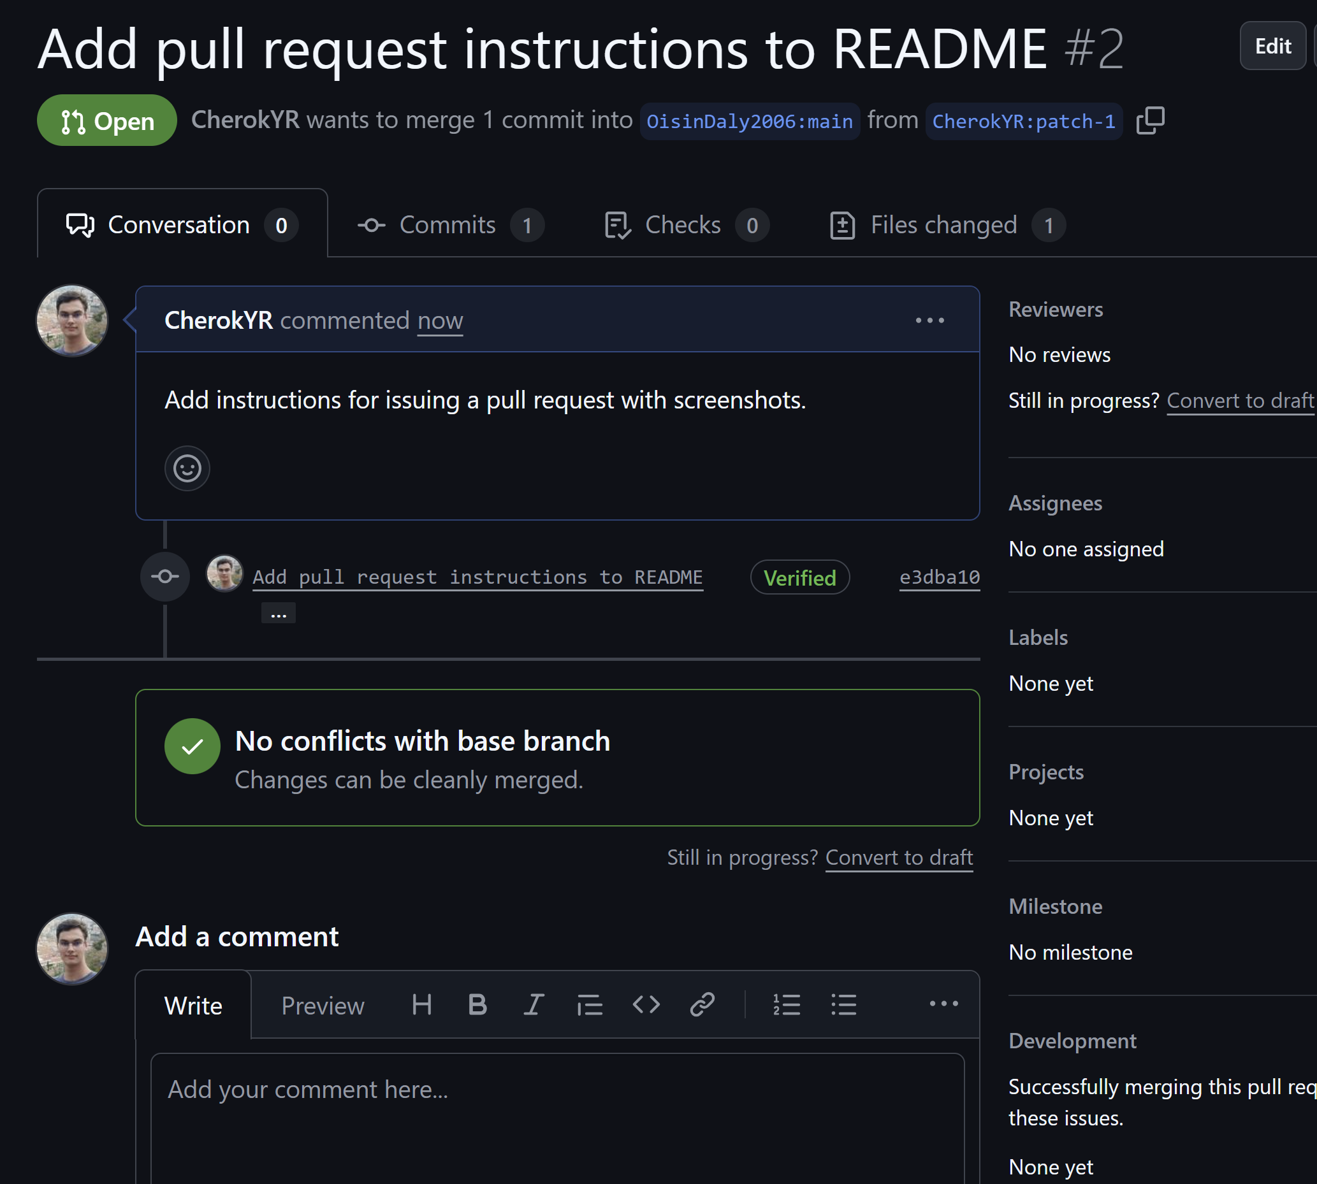

### **Arduino IDE & Coding Basics**

1. Find the Analog Read Serial sketch on the Arduino Website and get familiar with it:

[Analog Read Serial](https://docs.arduino.cc/built-in-examples/basics/AnalogReadSerial/)

1. Open the Potentiometer sketch on the Wokwi emulator here: <https://bit.ly/3UtAg25>   
   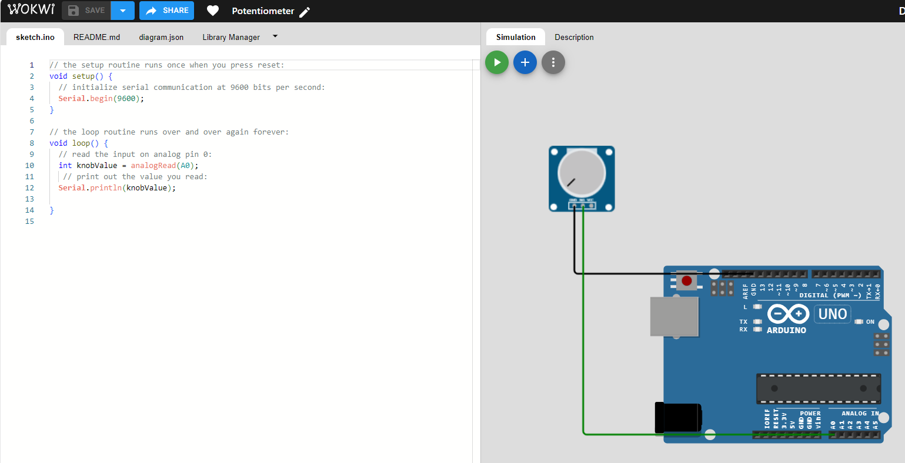
2. Run the sketch and note the values changing when you turn the Potentiometer
3. What ports are the Potentiometer connected to? To GND and A0
4. Add an LED to the sketch
5. Wire one side of the LED to a GND (Ground) port on the board
6. Wire the other side of the LED to Digital Port 2
7. Write code in the Loop() method to detect values of over 400 coming from the Potentiometer and in response to this level, light up the LED
8. Add a screenshot of your code changes here:

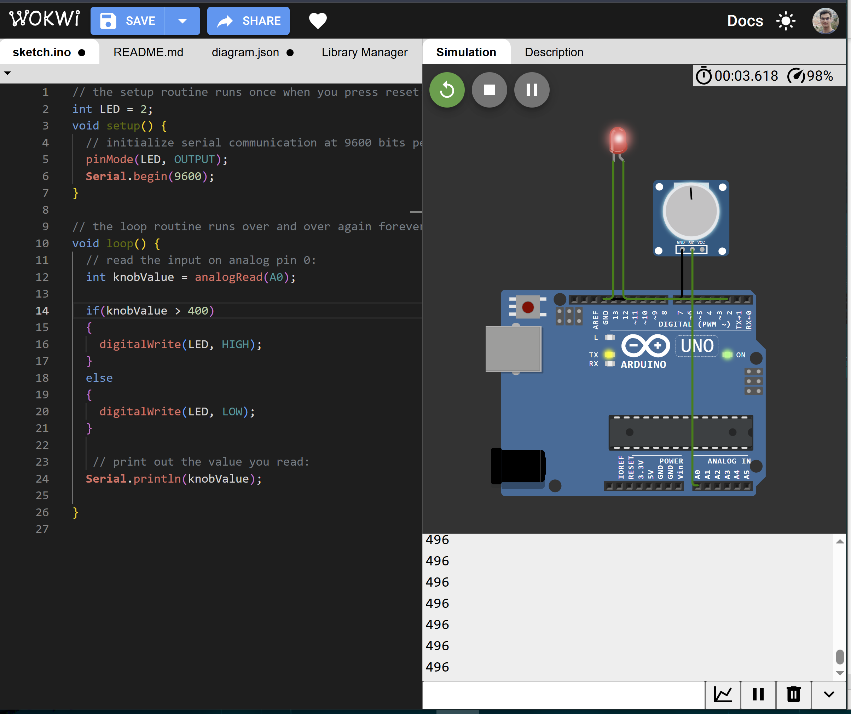

1. Now try this using the Grove Kit and Arduino: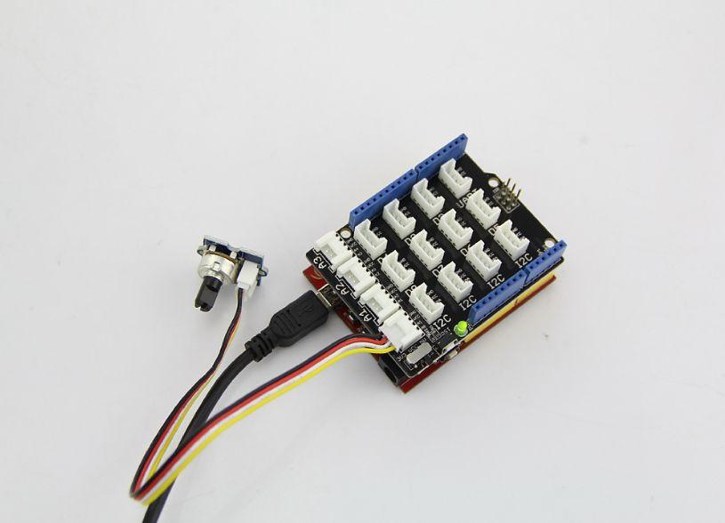
2. Take a photo of your implementation and post it here.

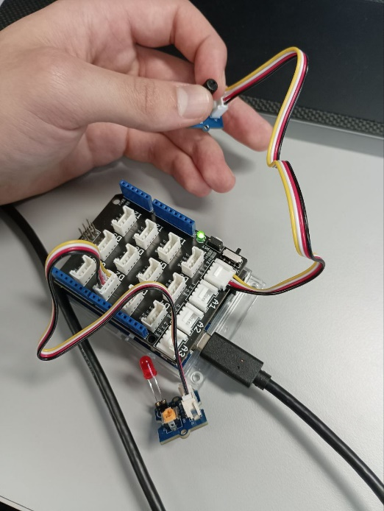

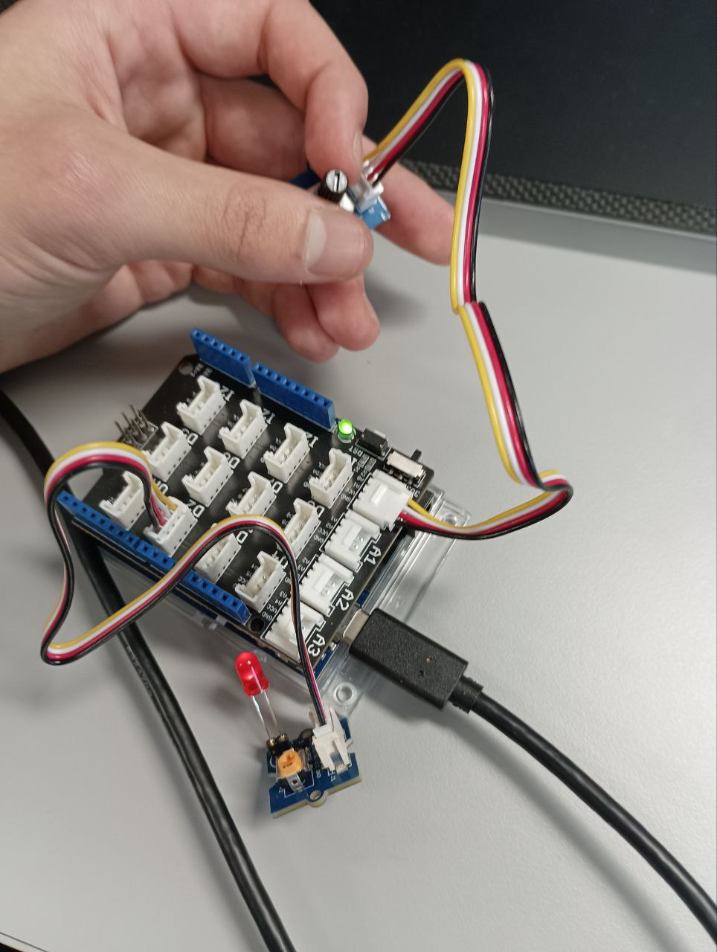

1. Add the modified code to your Github Account and provide the link here:

|  |
| --- |
| https://github.com/CherokYR/secondrepo-/blob/main/Modified%20code |

1. Replace the Potentiometer with another analog sensor - post a picture of your implementationand and think of a use for this setup:

|  |
| --- |
|  |

1. **Upload your Lab to Moodle!**